**Advanced driver assistance system**

#### A Project Report Submitted in partial fulfillment of the requirements for the award of the degree of

**BACHELOR OF TECHNOLOGY**

**in**

**COMPUTER SCIENCE AND ENGINEERING**

#### By

**B Simon Sumanth (2000030343)**

**Mohammad Fauzaan Pasha (2010030452)**



**DEPARTMENT OF COMPUTER SCIENCE AND ENGINEERING**

**K L DEEMED TO BE UNIVERSITY AZIZNAGAR, MOINABAD, HYDERABAD-500 075**

**APRIL 2024**

##### BONAFIDE CERTIFICATE

This is to certify that the project titled **“Advanced driver assistance system”** is a bonafide record of the work done by

**B Simon Sumanth (2000030343)**

**Mohammad Fauzaan Pasha (2010030452)**

in partial fulfillment of the requirements for the award of the degree of **Bachelor of Technology** in **COMPUTER SCIENCE AND ENGINEERING** of the **K L DEEMED TO BE UNIVERSITY, AZIZNAGAR, MOINABAD, HYDERABAD-500 075**, dur-

ing the year 2023-2024.

##### Dr. Shadab Siddiqui Dr. Arpita Gupta

Project Guide Head of the Department

Project Viva-voce held on

##### Internal Examiner External Examiner

**ABSTRACT**

Deep learning-based traffic sign identification, especially using Convolutional Neural Networks (CNNs) such as YOLOv8, has emerged as a potent technique for improving intelligent transportation systems.

The development of driver-assistance technologies, driverless cars, and smart city projects all depend on accurate traffic sign detection. This project uses the advanced object detection model YOLOv8 to overcome this difficulty. Using a large dataset of annotated traffic signs from Kaggle, which includes a variety of signs found on both city and interstate routes, our goal is to create a reliable system that can identify and locate these visual signals in photos. Numerous fields might undergo a revolution because to this method. In the context of autonomous vehicles, it could enable these vehicles to comprehend traffic laws, resulting in safer travel. This technology might be used by driver-assistance systems to give notifications in real-time about traffic signs and any infractions, encouraging more responsible and informed driving. Moreover, the research has the potential to improve road safety education initiatives by producing lifelike traffic models. In conclusion, this system has the potential to enhance the infrastructure of smart cities by providing real-time traffic sign compliance monitoring and distribution analysis, which may drive urban planning initiatives aimed at enhancing traffic flow and safety.

##### ACKNOWLEDGEMENT

We would like to thank the following people for their support and guidance without whom the completion of this project in fruition would not be possible. **Dr. Shadab Siddiqui**, our project guide, for helping us and guiding us in this project.

**Dr. Arpita Gupta**, the Head of the Department, Department of Computer Science and Engineering. Our internal reviewers, **Dr. Pavan Kumar**, **Mr. N Chiranjeevi**, **Mrs. B Uma Rani and Mr. Anantha Reddy** for their insight and advice provided during the review sessions. We would also like to thank our individual parents and friends for their constant support.

**TABLE OF CONTENTS**

##### Title Page No.

##### ABSTRACT ii

##### ACKNOWLEDGEMENT iii

##### TABLE OF CONTENTS iv

##### Introduction 6

* 1. Background of the Project 6
  2. Problem Statement 6
  3. Objectives 7
  4. Scope of the Project 7

##### Literature Review 8

* 1. Literature Review in tabular format 8
  2. Advantages and Limitations of existing systems 12

##### Proposed System 13

|  |  |  |
| --- | --- | --- |
| 3.1 | System Requirements . . . . . . . . . . . . . . . . . . . . . . . . . . . | 13 |
| 3.2 | Algorithms and Techniques used . . . . . . . . . . . . . . . . . . . . . | 13 |

##### Implementation 14

* 1. Tools and Technologies used 14
     1. Deep Learning Frameworks………………………………………..14
     2. Pre-Trained Models………………………………………………...14
  2. Modules and their descriptions 15
  3. Flow of the System 16
     1. Flowchart 17

1. Results and Analysis 18
   1. Performance Evaluation 18
      1. Accuracy 18
      2. Precision 18
      3. Recall(sensitivity) 18
      4. F1 Score 19
      5. Confusion Matrix 19
   2. Comparison with existing systems 19
   3. Limitations and future scope 20
2. Conclusion and Recommendations 21
   1. Summary of the Project 21

References 23

Appendices 24

A Source code 25

1. Data sets used in the project 35

**Chapter 1 Introduction**

* 1. **Background of the Project**

For the purpose of maintaining road safety and controlling traffic flow, traffic signs are essential. However, variables like changing weather, occlusions, or broken signs frequently cause problems for existing techniques of traffic sign identification. This study explores the use of deep learning for reliable identification of traffic signs. Deep learning models are perfect for this purpose because they can extract intricate patterns from large volumes of data. The research intends to construct a system that can precisely detect and locate these indicators inside photos by utilizing a vast collection of annotated traffic signs. This has great promise for a number of uses, such as driver-assistance programs, driverless cars, and smart city projects.

* 1. **Problem Statement**

There are several obstacles in the way of the crucial duty of accurately identifying traffic signs in real-world situations. Conventional techniques that rely on color or form thresholds are vulnerable to changes in the weather, illumination, and even small degradations in the signs themselves. Accurate identification is further complicated by the wide variety of traffic signs and the possibility of obstacles like trees or cars blocking them. The goal of this research is to construct a deep learning-based system for reliable traffic sign identification in order to overcome these constraints. The research seeks to achieve high accuracy in detecting and localizing traffic signs even in complicated visual situations by utilizing deep learning models to extract significant characteristics from picture data. This enhanced detecting capacity can help progress driver-assistance technologies, driverless cars, and smart city infrastructure.

* 1. **Objectives**

Build a model that can precisely locate and recognize different traffic signs even under difficult situations like fading light, inclement weather, or partially occluded signs. Applications in driver assistance systems, driverless cars, and smart city infrastructure may be made possible by the ability to recognize traffic signs, which may ultimately result in safer and more effective transportation.

* 1. **Scope of the Project**

Utilizing a pre-existing, well-established deep learning model for object detection, rather than building one from scratch. Training this model on a comprehensive dataset of annotated traffic signs sourced from Kaggle. This dataset will include a wide variety of signs commonly encountered on roads and highways. Evaluating the model's performance on a separate validation set to ensure its effectiveness in identifying and localizing traffic signs with high accuracy.

**Chapter 2** **Literature Review**

* 1. **Literature Review in tabular format**

|  |  |  |  |
| --- | --- | --- | --- |
| Reference | Authors | Publication Date | Key Findings |
| Traffic Sign Detection and Recognition Using YOLO Object Detection Algorithm: A Systematic Review by Md. Rashedul Islam et al. (2023) | Md. Rashedul Islam et al. | 2023 | This paper reviews the application of YOLO for traffic sign detection. It compares different YOLO versions (v3, v5, etc.) and their effectiveness, highlighting YOLO's speed and accuracy for real-time systems.. |
| A Comparative Study of Deep Learning Methods for Real-Time Traffic Sign Detection by Shervan Amini et al. (2020). | Shervan Amini et al. | 2020 | This paper compares various deep learning architectures (SSD, YOLOv3, Faster R-CNN) for real-time traffic sign detection. It highlights the trade-off between accuracy and processing speed, providing valuable insights for choosing an appropriate model for your project. |
| Real-Time Traffic Sign Detection and Recognition with Deep Convolutional Neural Networks by Pei Wang et al. (2019). | Pei Wang et al. | 2019 | While this paper uses Faster R-CNN, it explores real-time traffic sign detection with deep learning. The findings emphasize the importance of balancing accuracy and speed for practical applications. |
| SSD: Single-Shot MultiBox Detector by Wei Liu et al. (2016). | Wei Liu et al. | 2016 | This paper introduces the Single-Shot MultiBox Detector (SSD) framework. Understanding SSD's functionalities and its comparison with YOLOv8 can provide a broader perspective on object detection approaches for traffic signs. |
| Deep Learning for Computer Vision by Adrian Rosebrock (2018). | Adrian Rosebrock | 2018 | This book offers a practical introduction to deep learning for computer vision. It can be a valuable resource for understanding the fundamentals of object detection frameworks like YOLOv8. |
| Deep Residual Learning for Image Recognition by Kaiming He et al. (2015) | Kaiming He et al. | 2015 | This paper introduces the ResNet architecture, a deep CNN model with residual connections. ResNets have become popular for traffic sign detection due to their ability to handle deeper network architectures and improve accuracy. |
| Traffic Sign Recognition with Deep Learning for Autonomous Vehicles by Tareq Rashid et al. (2020). | Tareq Rashid et al. | 2020 | This paper explores traffic sign detection for autonomous vehicles using deep learning, focusing on Faster R-CNN. It investigates the challenges of real-world scenarios like occlusions and variations in lighting, demonstrating the effectiveness of deep learning in overcoming these challenges. |
| Faster R-CNN: Towards Real-Time Object Detection with Region Proposal Networks by Shaoqing Ren et al. (2015) | Shaoqing Ren et al. | 2015 | This paper introduces the Faster R-CNN architecture, building upon the success of R-CNN by introducing a Region Proposal Network (RPN) for efficient proposal generation. Faster R-CNN offers a balance between accuracy and speed, making it suitable for real-time traffic sign detection applications. |
| Exploring the Limits of Weakly-Supervised Deep Learning for Traffic Sign Detection by Kevin Duarte et al. (2020) | Kevin Duarte et al. | 2020 | This paper investigates weakly-supervised learning for traffic sign detection. Weakly-supervised learning utilizes image-level labels instead of precise bounding box annotations, potentially reducing annotation effort. The study explores the feasibility and limitations of this approach for traffic sign detection. |
| Attention-based Deep Learning Framework for Traffic Sign Detection and Recognition by Yuhua Hu et al. (2022) | Yuhua Hu et al. | 2022 | This study investigates the use of attention mechanisms in a deep learning model for traffic sign detection. Attention mechanisms allow the model to focus on critical regions within an image, potentially improving detection accuracy for small or partially occluded signs. |

* 1. **Advantages and Limitations of existing systems**

Pre-established rules based on color, shape, or size are frequently used by traffic sign detecting systems that are now in use. Although these techniques work well in controlled settings, they are less successful in practical situations. They are vulnerable to changes in the weather, lighting, and even small damage to signs. Further impeding their accuracy are the wide variety of traffic signs and possible object occlusions. Deep learning is more resilient to these difficulties because it can identify intricate patterns from enormous volumes of data, which is a big benefit. Nevertheless, deep learning techniques can have drawbacks. The caliber and volume of the training data are critical to the performance of these systems. Furthermore, a significant amount of computer power may be needed to train deep learning models

**Chapter 3**

**Proposed System**

* 1. **System Requirements**

HARDWARE REQUIRMENTS & SOFTWARE REQUIRMENTS

Hardware Requirements:

Processor: intel

Memory Space: 8gb

RAM: 16 gb

Windows, linux

Software Requirements:

Operating System – windows 10 or higher.

* 1. **Algorithms and Techniques used**

This research uses a deep learning methodology based on Convolutional Neural Networks (CNNs) to address traffic sign identification. It specifically makes use of YOLOv8, a cutting-edge object identification model renowned for its quickness and precision. CNNs are perfect for this purpose since they are excellent at identifying patterns in pictures. To capitalize on this, YOLOv8 analyzes a picture and forecasts bounding boxes surrounding possible items (traffic signs) in addition to their class probability. This enables the model to recognize the existence of a sign and assign it to the appropriate category (such as a yield sign or stop sign). The project's goal is to produce robust traffic sign identification that outperforms conventional algorithms by utilizing YOLOv8..

**Chapter 4 Implementation**

## Tools and Technologies used

For conducting experiments related to traffic signs and signals detection using Convolution Neural Network (CNN), YOLOv8, various tools and technologies are essential.

### Deep Learning Frameworks

A project description is a high-level overview of why you’re doing a project. The docu- ment explains a project’s objectives and its essential qualities. Think of it as the elevator pitch that focuses on what and why without delving into how.

### Pre-Trained Models

YOLOV8 is a pre-trained CNN model that can be fine-tuned for object detection not solely classification or identification. It is a part of the YOLO family of models known for their simplicity and effectiveness.

ResNet, Inception, MobileNet, etc.: Various pre-trained CNN architectures are available for transfer learning, where you adapt existing models to your specific task.

## Modules and their descriptions

* OpenCV: OpenCV is a powerful computer vision library that can be used for image processing and manipulation, including resizing, color normalization, and data augmentation.
* Data Augmentation Libraries: Libraries such as Keras' ImageDataGenerator or TensorFlow's tf.image provide functions to augment the dataset with techniques like rotation, flipping, and brightness adjustments.
* Visualization Libraries: Libraries like Matplotlib, Seaborn, and TensorBoard (for TensorFlow) are used for visualizing model performance and results.
* Hyperparameter Optimization Tools: Tools like Keras Tuner, Optuna, and scikit-optimize can assist in optimizing hyperparameters for model performance.

These tools and technologies helped design, train, and evaluate CNN models for traffic signs and signal detection.

## Flow of the System

Leveraging the power of YOLOv8, a state-of-the-art object detection model, this system tackles traffic sign and signal detection. The first step involves compiling a large collection of tagged photos of traffic signs and signals from sites such as Kaggle. Data pre-processing, which may involve scaling and normalization, guarantees image quality and consistency. Data augmentation methods might be used to enhance the model even further. For the purpose of training and evaluating the model, the prepared dataset is then carefully split into training, validation, and test sets. The particular traffic sign and signal dataset is used to fine-tune YOLOv8, which has been pre-trained for object recognition. In order to avoid overfitting, training entails improving the model using appropriate loss functions and techniques while keeping a close eye on the validation set.Finally, using measures like accuracy and precision, the model's performance is carefully evaluated on the test set that has not yet been observed. The model's detecting skills can be improved by additional fine-tuning if needed. When a dependable model is developed, it may be used in practical applications like as driver-assistance programs, autonomous cars, and traffic control in smart cities, which will ultimately lead to more effective and safe transportation.

### Flow Chart

Test

Data

Validation

Data

Training

Data

Training by YOLOv8

Testing

Custom Weights

Evaluation on test data of other datasets

Evaluation on validation of other datasets

To train an object detection model like YOLOv8, one typically starts by preparing a custom dataset consisting of annotated images with bounding boxes around objects of interest. This dataset is divided into training, validation, and test sets. Training data is used to optimize the model's parameters during training, while validation data helps in tuning hyperparameters and monitoring the model's performance during training. After training, custom weights specific to the trained model are obtained. These weights are then used for testing, where the model's performance is evaluated on both the validation data and test data from the same or different datasets, measuring metrics like precision, recall, and mAP (mean Average Precision) to assess its accuracy and generalization ability on unseen data.

**Chapter 5 Results and Analysis**

## Performance Evaluation

Performance evaluation in a project for traffic signs and signals detection using YOLOv8 and CNNs is crucial to assess the effectiveness of the developed model.

### Accuracy:

Accuracy is a fundamental metric that measures the overall correctness of the model's predictions. It is the ratio of correctly detecting traffic signs and signals to the total number of samples in the test dataset.

### Precision:

Precision measures the model's ability to make correct positive predictions (e.g. detecting traffic signs and signals) among all positive predictions. It helps to assess the model's capability to avoid false positives.

### Recall (Sensitivity):

Recall, also known as sensitivity, evaluates the model's ability to correctly identify all positive cases. It is the ratio of correctly identified positive cases to the total number of actual positive cases.

### F1 Score:

The F1 score is the harmonic mean of precision and recall. It provides a balanced measure of both precision and recall and is especially useful when there is an imbalance between positive and negative classes.

### Confusion Matrix:

A confusion matrix provides a detailed breakdown of the model's predictions, including true positives, true negatives, false positives, and false negatives. It's a valuable tool for understanding the model's performance in different scenarios.

## Comparison with existing systems

### 

### This YOLOv8-based system has several benefits over conventional traffic sign identification techniques that depend on color thresholds or preset templates. Conventional techniques have trouble with changes in weather, illumination, and sign deterioration. Deep learning model YOLOv8 is very good at finding patterns in complicated data. It achieves improved resilience by being trained on a large dataset that includes a variety of indicators. This initiative paves the way for developments in fields where dependable sign identification is essential for safety, such as driverless cars and driver-assistance systems, by providing a more flexible and precise solution for traffic sign detection.

### Data Quality and Quantity:

### Evaluate the quality and size of your dataset compared to datasets used by existing systems. A larger, more diverse dataset can improve model performance.

### Model Architecture:

### Compare your chosen model architecture (e.g., YOLOv8) with architectures used in existing systems. Assess if your choice is more suitable for traffic signs and signals detection.

## Limitations and future scope

Maintenance and Updates: Keeping the model up-to-date and continuously improving its performance can be resource-intensive. A robust strategy for model maintenance and updates is essential for long-term viability.

Lighting and Environmental Factors: Variability in lighting and environmental conditions may affect the model's performance. The system may not perform optimally in scenarios with poor lighting or extreme environmental conditions.

Transfer to Other Industries: The technology and expertise gained from traffic signs and signals detection can be applied to other domains, such as public transportation and emergency services.

Efficiency Optimization: Research can continue to develop more efficient architectures or techniques that achieve similar or better performance with reduced computational resources, enabling broader adoption.

**Chapter 6**

**Conclusion and Recommendations**

## Summary of the Project

This research uses deep learning to address the important problem of robust traffic sign detection. Conventional techniques that rely on color thresholds or predefined templates have trouble adapting to changes in the weather, lighting, or even little damage to signs.

Here, we use the most recent object detection model, YOLOv8, to get beyond these restrictions. The first step of the research is to gather a large dataset of photos of labeled traffic signs, most likely from websites like Kaggle. This collection includes a large range of signs that are frequently seen on roads and highways. Data pre-processing, which may involve methods like scaling and normalization, guarantees image quality and consistency. In order to increase the resilience of the model even further, data augmentation techniques might be used to fictitiously grow the dataset with changes.

Next, the prepared dataset is carefully split into test, validation, and training sets. After being pre-trained for object detection tasks, YOLOv8 is refined using a particular dataset of traffic signs. The model's capacity to identify the wide variety of traffic signs in the dataset is customized through this fine-tuning procedure. In order to avoid overfitting, training entails refining the model using appropriate loss functions and optimization methods while keeping a close eye on the validation set. Finally, using measures like accuracy and precision, the model's performance is carefully evaluated on the test set that has not yet been observed. The model's detecting skills can be improved by additional fine-tuning if needed.

When a dependable model is developed, interesting applications in real-world situations become possible. This includes driver-assistance systems that offer real-time alerts on traffic restrictions, autonomous cars that depend on precise sign recognition for safe navigation, and smart city traffic management that gains from effective sign monitoring. In the end, our YOLOv8 initiative makes transportation safer and more effective by providing reliable and flexible traffic sign recognition.

**References**

* + 1. Díaz-Gamero, Sergio, et al. "A Deep Learning Approach for Traffic Sign Detection and Classification in Urban Environments." Sensors 19.11 (2019): 2676.
    2. Real-Time Traffic Sign Detection and Recognition with Deep Convolutional Neural Networks by Pei Wang et al. (2019): www.researchgate.net/publication/

224255280_Real-time_traffic_sign_recognition_system

* + 1. SSD: Single-Shot MultiBox Detector by Wei Liu et al. (2016): https://arxiv.org/abs/1512.02325 (This paper introduces the Single-Shot MultiBox Detector (SSD) framework).
    2. Traffic Sign Recognition based on Deep Learning by Muhammad Aamir et al. (2022): https://link.springer.com/chapter/10.1007/978-981-19-2350-0_34 (This paper provides a general overview of deep learning for traffic sign recognition).
    3. Deep Residual Learning for Image Recognition by Kaiming He et al. (2015): https://arxiv.org/abs/1512.03385 (This paper introduces the ResNet architecture, commonly used in traffic sign detection models).
    4. Traffic sign recognition with deep learning for autonomous vehicles by Tareq Rashid et al. (2020): https://ir.vignan.ac.in/678/1/85.V.Nagireddy%20JOICS-5892.pdf (This paper explores traffic sign detection for autonomous vehicles)
    5. German Traffic Sign Detection Benchmark (GTSDB) by Bastian Leibe et al. (2008): https://noureldien.com/content/hussein2015hierarchical.pdf (A popular benchmark dataset for traffic sign detection).
    6. Deep Learning for Computer Vision by Adrian Rosebrock (2018): https://pyimagesearch.com/deep-learning-computer-vision-python-book/

# Appendices

# Appendix A Source code

A The project titled "Advanced driver assistance system" is a cutting-edge initiative aimed at revolutionizing traffic signs and signals detection assessment through the power of deep learning and YOLOv8. This project addresses a pivotal issue in the road and transport department, where the accurate detection of traffic signs and signals is essential for the latest automobile which use autopilot and helps to reduce traffic and road accidents.

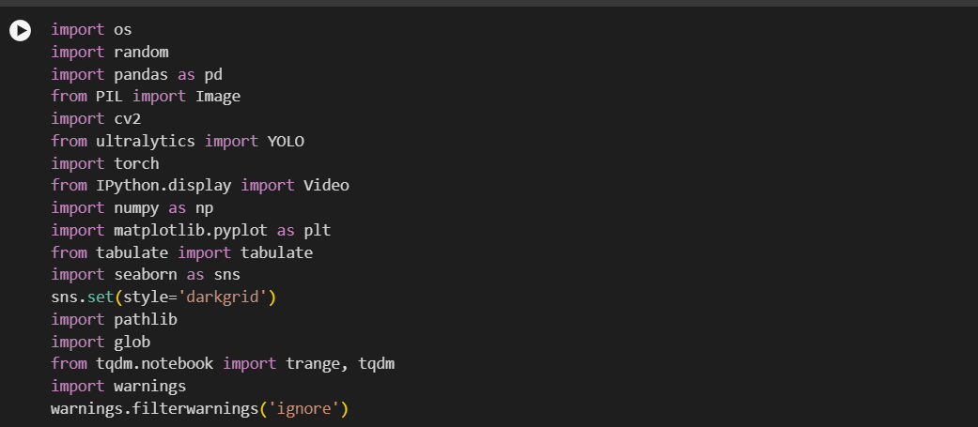

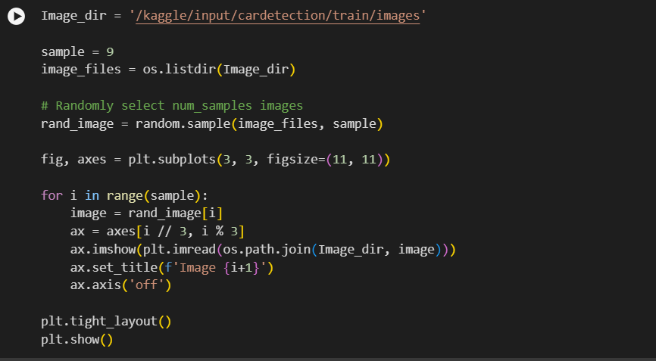

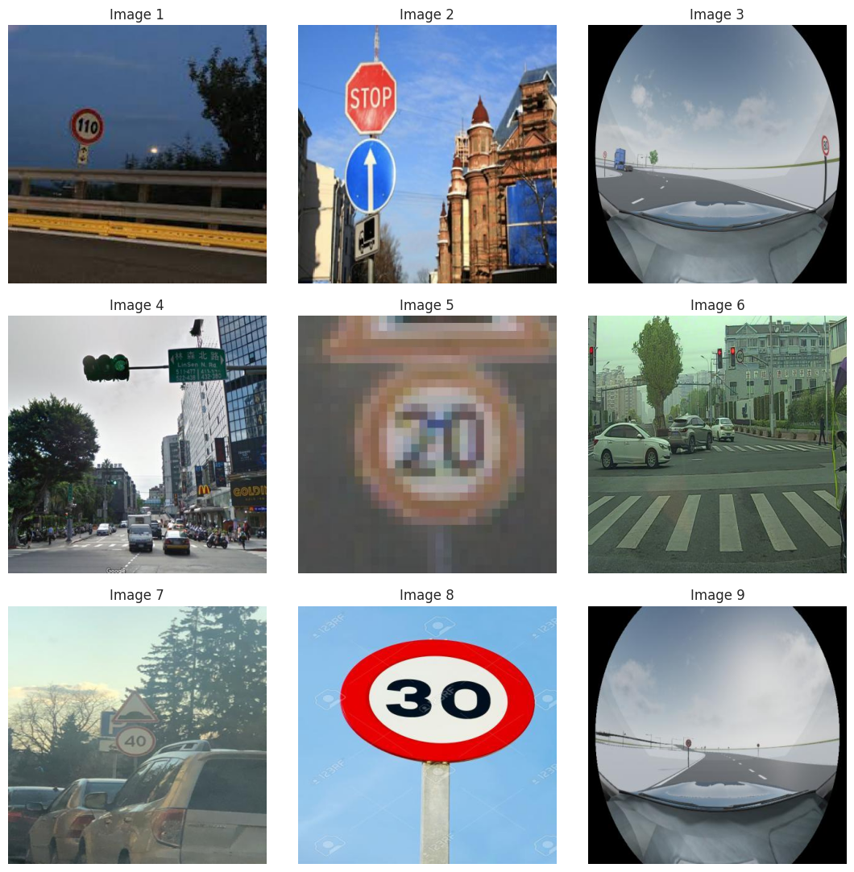

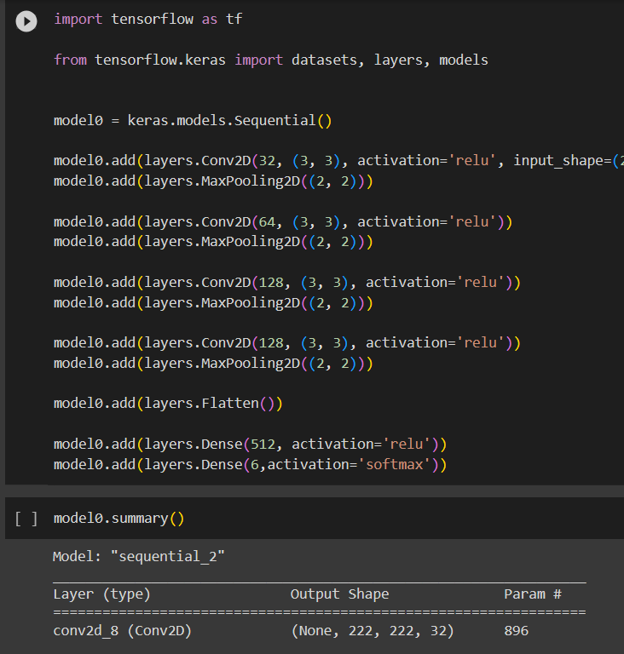

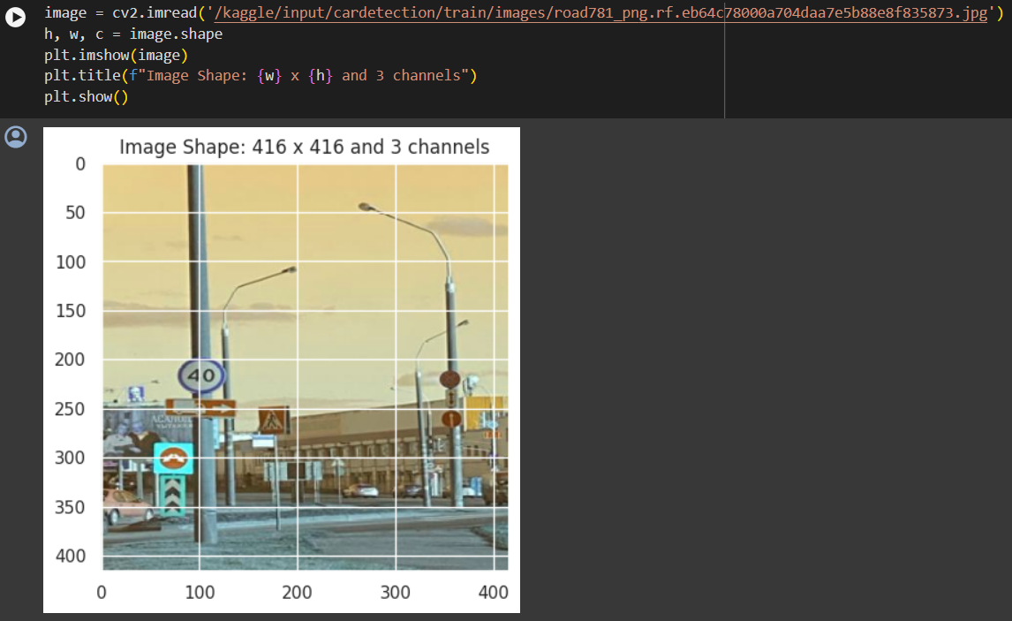

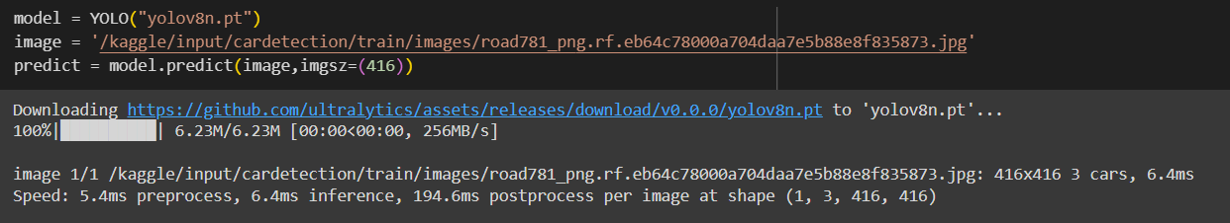

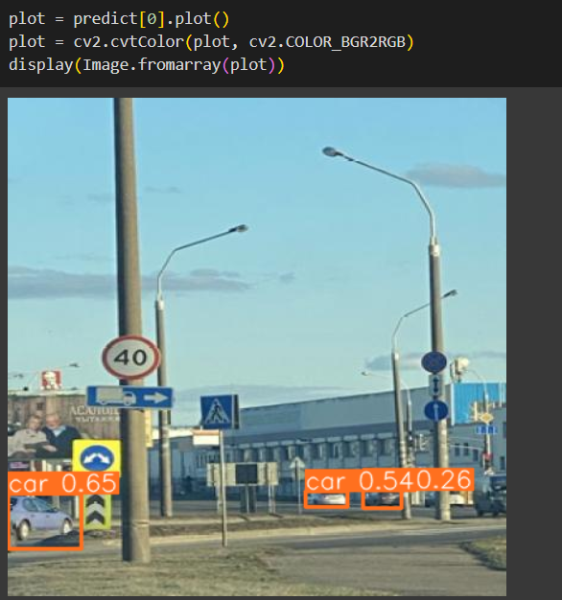



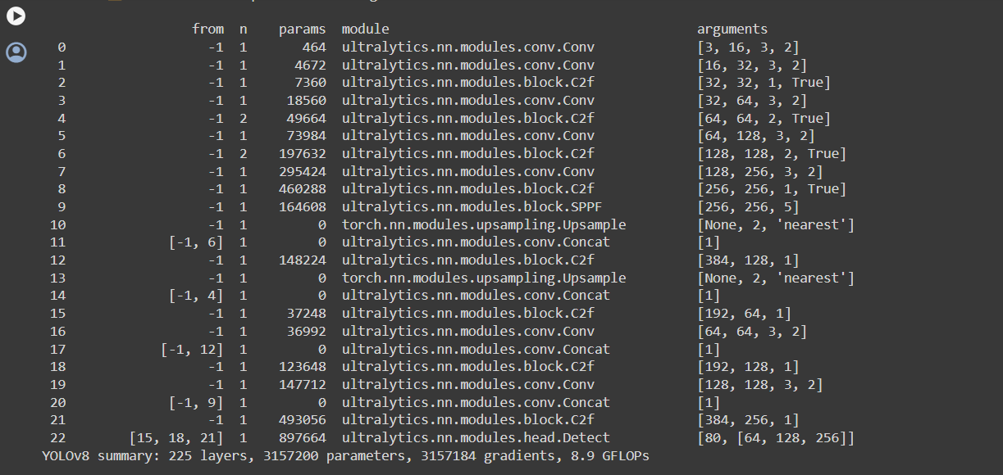

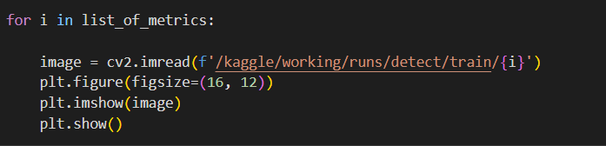

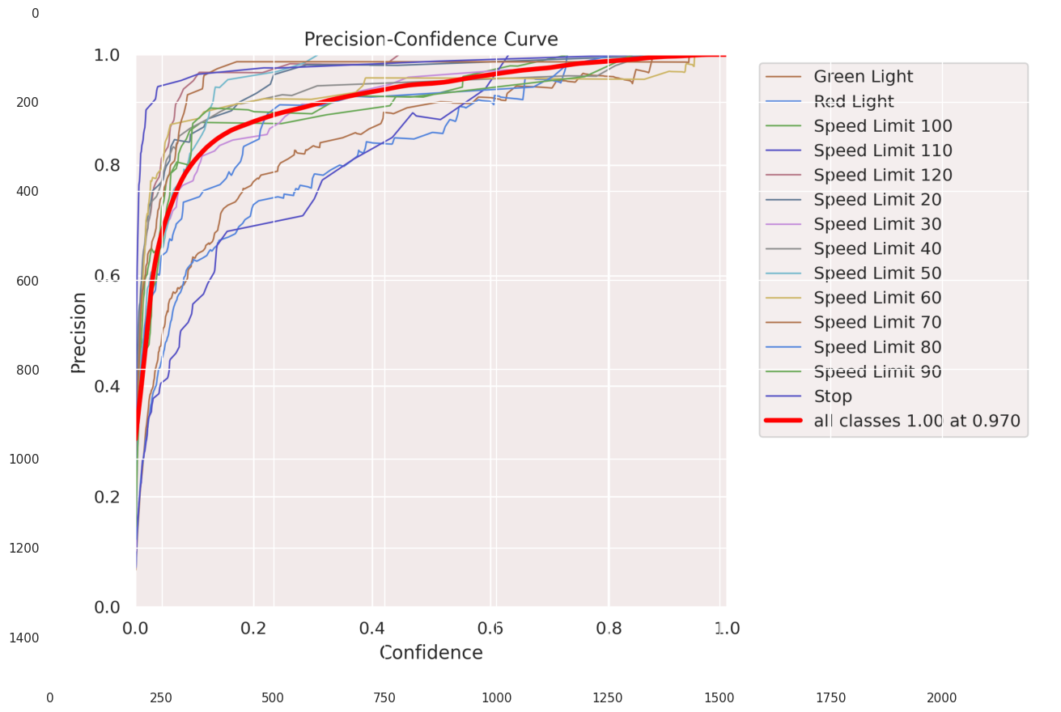

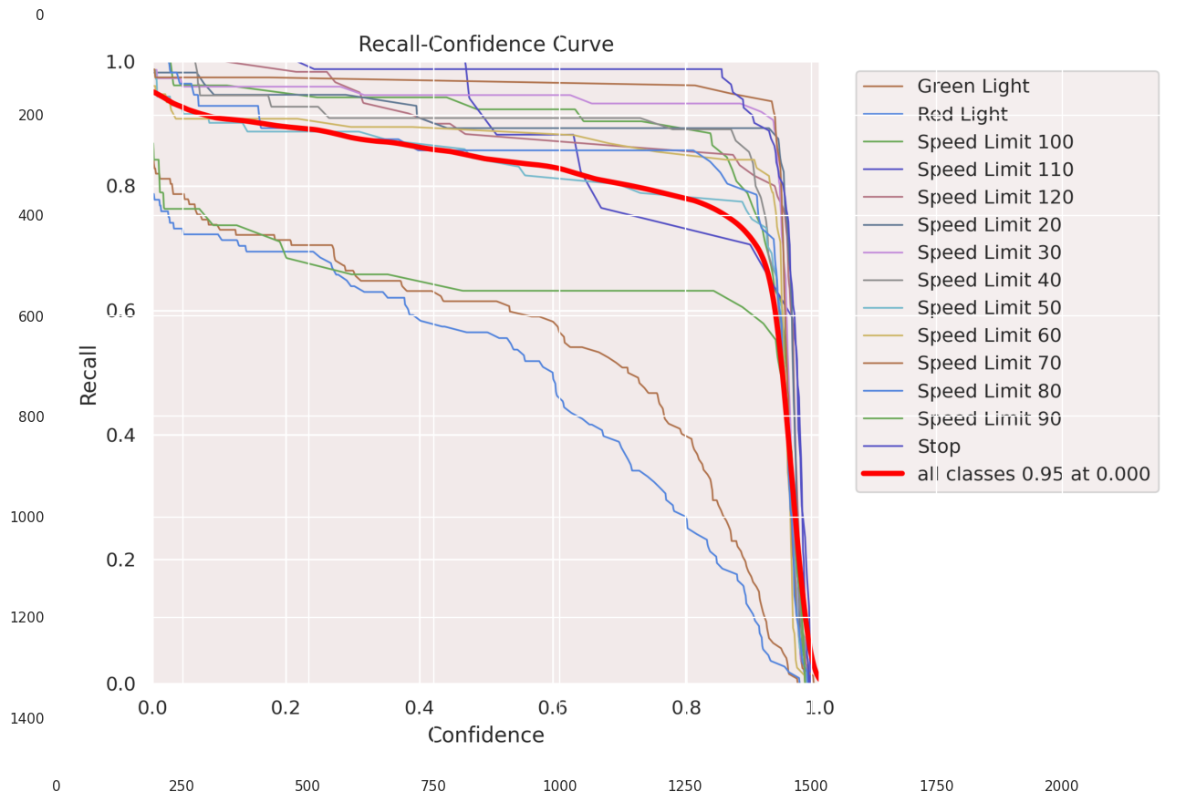

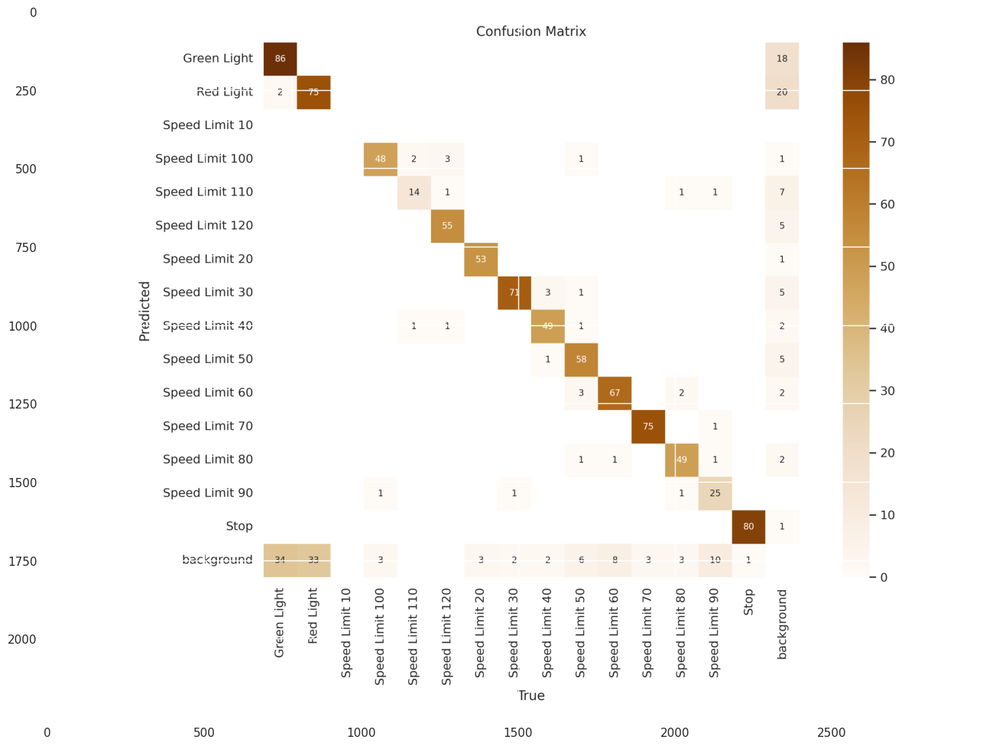

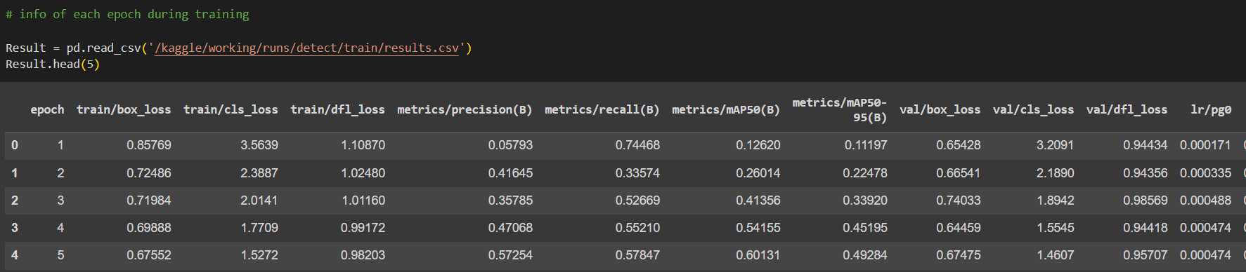

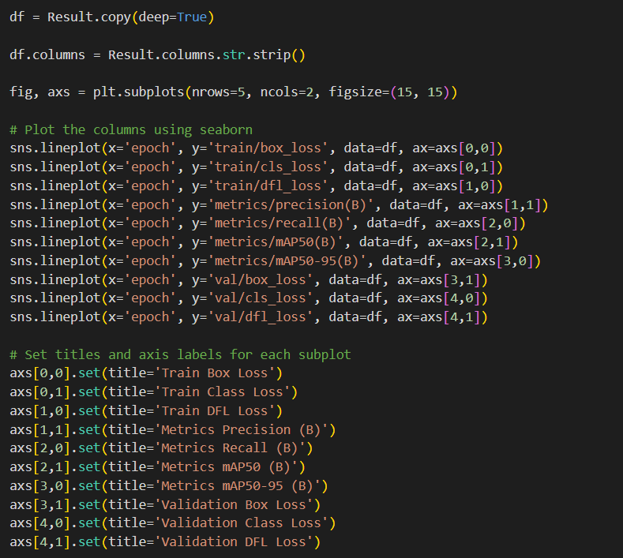

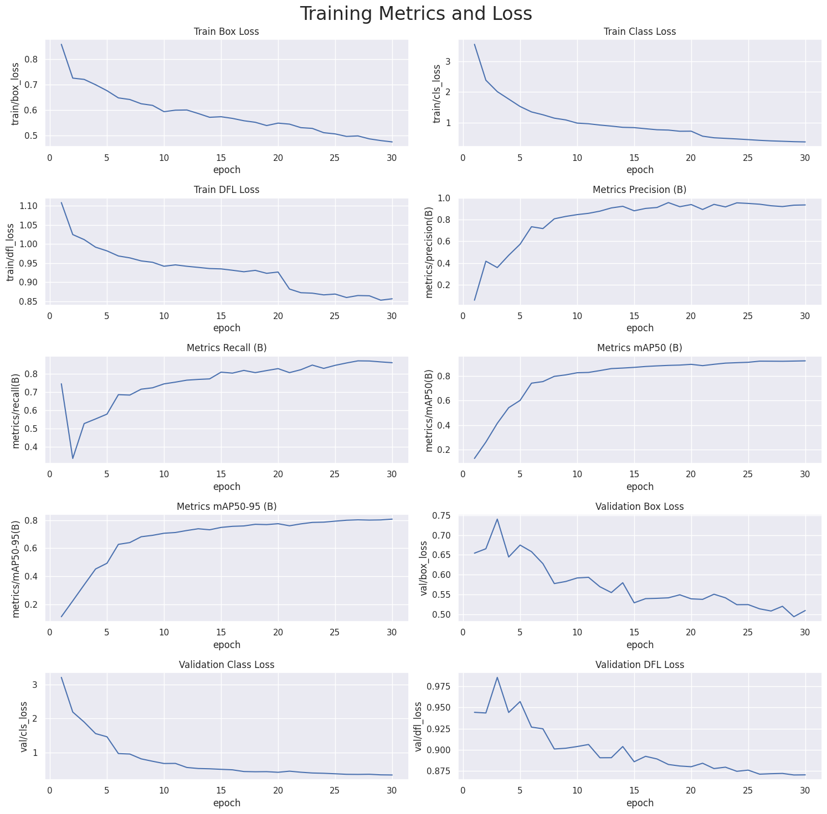

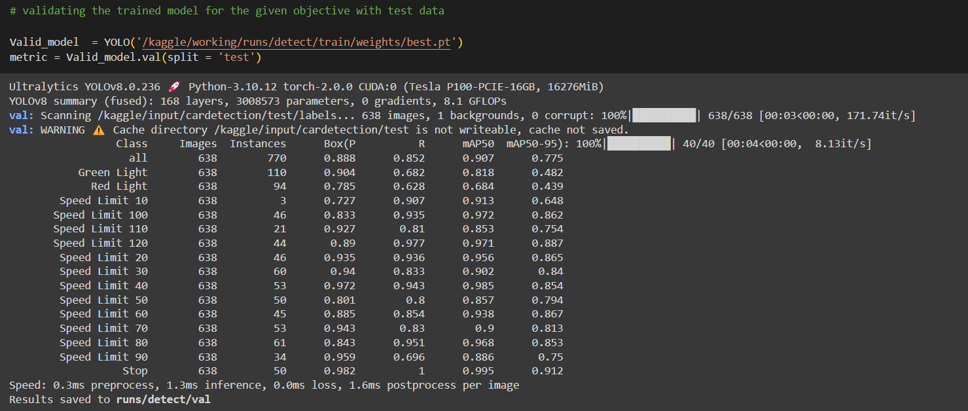

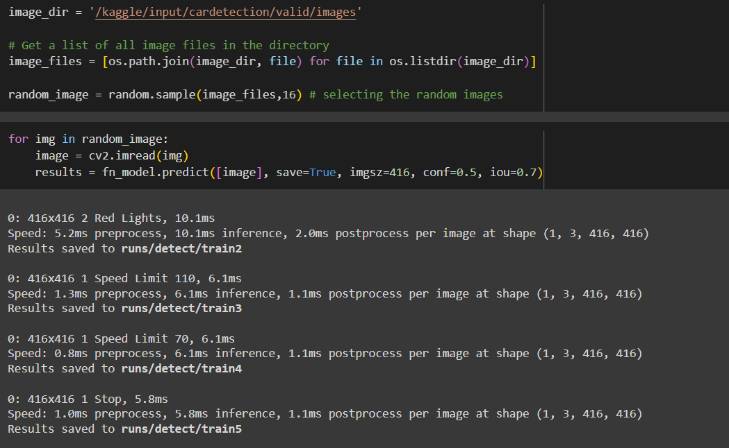

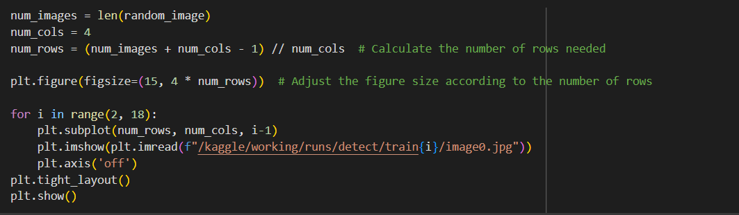

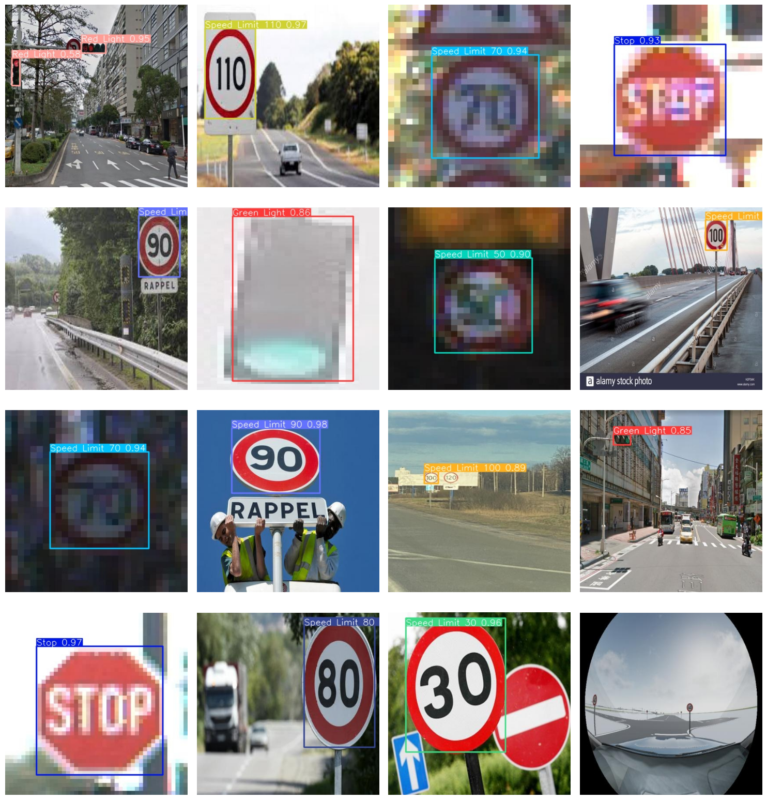

**Appendix B**

**Data sets used in the project**

<https://www.kaggle.com/datasets/pkdarabi/cardetection>

Description:

The "Advanced driver assistance system" project is a data-driven initiative designed to address the critical challenge of detecting traffic signs and signals at a high-speed using machine learning techniques.

This dataset is a traffic sign image dataset containing 4969 samples, which dataset (as you can see in the image) is correctly divided into three parts: Train,Valid,Test!!

